ORGANISATION PROFILE

CMPDI has 30 years of experience as India’s one of the largest consultancy organisation. The Organisation is accredited with ISO-9001 Certificate by Certification International (United Kingdom). CMPDI is a premier consultant in open pit and underground mine planning and design in coal, lignite and other minerals. It holds a position of eminence in the field of environmental engineering both in coal and other sectors. CMPDI has well equipped network of 6 laboratories to monitor air, water, and noise parameters. New generation exploration technology coupled with skilled manpower has made CMPDI leader in mineral exploration, resource evaluation, resource management & mining geology.

CMPDI is registered consultants to:

- World Bank, Washington
- Asian Development Bank, Manila
- United Nations Development Programme (UNDP)
- National Development Corporation, Tanzania
- Ministry of Mines & Petroleum, Muscat, Sultanate of Oman
- Ministry of Coal Industry, Peoples' Republic of China
- African Development Bank, Abidjan

CMPDI is having MoU with:
- IMCL, UK
- METCHEM, Canada
- Giproshakht, Russia
- Montan Consulting GmBH, Germany
- Rheinbraun Engineering, Germany
- DMT, Germany

The Environment Division of CMPDI undertakes and offers consultancy to CIL units as well as to non-CIL client in the following fields:

- Baseline data generation which includes:
  - Meteorological data
  - Land use plan
  - Air quality - ambient & work zone
  - Water quality
  - Noise level measurement
  - Soil sampling & analysis
  - Flora and fauna studies
- Environmental Impact Assessment
  - Land degradation
  - Impact on flora and fauna
  - Air, water and noise pollution
  - Social impact

- Environmental Management Plan
  - Land reclamation plan
  - Air, Water & noise abatement measures
  - Green belt development
  - Rehabilitation & Resettlement plan
  - Subsidence prediction studies and management
  - Ecological restoration

- Environmental Monitoring(Air/water/noise parameters)
- Environment Auditing/Statement
- Biological Reclamation Studies
- Thematic Mapping through Satellite and Air- borne Scanning
- Rain water harvesting schemes
- OB dump reclamation studies
- Dust survey
- Environmental engineering
  - Planning & design of effluent/sewage treatment facilities
  - Water supply distribution network and water treatment facilities

- Zoning Atlas studies
- Eco-city planning
- Capacity Building
- Environmental planning for eco-sensitive regions
- Environmental planning for eco-sensitive regions
- EIA/EMP relating to Flyash as backfilled material
- R& D projects

Services Provided by CMPDI are as follows: -
  - Exploration Services:

CMPDI has completed over 500 coal exploration projects in India in all types of terrain and geological set-up. This has resulted in providing 80 billion tonnes of coal. Annually, CMPDI carries out about 200,000 meters of drilling spread over seven States in India through 23 drilling camps.

  - Planning & Design Services:

CMPDI has comprehensive experience in dealing with mining projects having geo-structural complexities. CMPDI has planned about 700 projects for an additional capacity generation of over 500 million tonnes of coal per annum. It has developed expertise in the reconstruction of mines, conversion of underground mines into open cast, mining in rugged terrain.

  - Coal Preparation & Utilisation:

CMPDI offers complete consultancy services for coal washeries and mineral beneficiation.

  - Research & Development Services:

CMPDI has patented its own technology through development of Special Smokeless Fuel (SSF), the domestic coke. CMPDI is the nodal agency for S&T Projects sponsored by Ministry of Coal, Government of India and R&D projects executed by Coal India Limited

  - Environment Management Services:

The environmental laboratory is recognised by Central Pollution Control Board, Ministry of Environment & Forests, Government of India and accredited with ISO-9001 certification. It undertakes baseline environmental data generation, EIA, EMP and monitoring various factors related environment.

  - Information & Communication Technology Services:

ICT Division provides consultancy in various areas such as Networking (LAN, WAN & VPN), Database Administration, web design and GIS.

  - Management Services:

The spectrum of management services covers techno-economic feasibility study, sizing of equipment, finalisation of equipment parameters, development of conceptual design and detailed engineering, equipment specifications, BOQ, tender documents, vendor selection, preparation of contract agreement and site supervision for construction and consultancy & support for standardised Management Systems(e.g. ISO 9001 & its industry specific translations, ISO 14001 & OHSAS 18001)
  - Coal Technology & Laboratories:

CT & Laboratory Services division of CMPDI is a centre for excellence in resource quality evaluation, beneficiation and proper utilization of coal/lignite and minerals. Expert services are offered with highly skilled manpower and state-of the art equipments for characterisation of coal and lignite through chemical, petrographic and washability route supported by coal technologist for end use.

  - Specialised Services:

CMPDI provides specialised services in various areas such as Geomatics, Ventilation & Gas Survey in mines, Blasting services, non destructive testing and mine support design.

  - Mining Electronics:

Mining Electronics Division is actively associated with the identification and Implementation of Electronics & Control System for underground mines as well as opencast projects besides planning and design of communication network of subsidiaries for providing voice and data communication as a part of CoalNet project. Electronics Department is associated with laboratory activities pertaining to the repair and calibration of different gas detectors/monitors for underground mines based on the approval accorded by the DGMS authority as well as repairing of imported HEMM Electronics cards of 120T/170T/85T Dumpers, Shovels, Draglines & Drill etc.

  - Geomatics Services:

Geomatics Division offers its services in the field of Remote Sensing, GIS & GPS to mining as well as associated utility sectors; ranging from topographical survey, excavation monitoring, mineral exploration, water resource survey to land use mapping, environmental studies, disaster and utility management.

- Infrastructure & Expertise available at CMPDI:

  - LAN extending over 4 Buildings with optic fibre back bone
  - 128 kbps Dedicated Leased Line Internet Connection
  - Establishment of Intranet
  - Web hosting
  - E-mail services
  - Office automation
  - Web applications
  - Database design
  - Geographic Information System (GIS) Centre
  - Training Centre
  - Networking Solutions
  - Remote Access Server (RAS) for dial-up users
  - Remote Tender Uploading Multi Lingual MS Office

- Projects Completed by CMPDI:

  - Executive Information System for Coal India Limited
  - Computerised Maintenance Management System for Rajrappa Coal Washery
  - Digitisation and Creation Database of Coalfields for CCDA (Govt. of India)
  - Hospital Management System
  - Integrated Information system for Central Coalfields Limited
  - Daily Production Report System for Central Coalfields Limited
  - LAN Establishment in Central Coalfields Limited
  - Scheme for 10th Five year plan for Coal & Lignite Sector
  - GIS Centre at Western Coalfields Limited
  - Pilot project for Govt. of Jharkhand of GIS based database for Koderma District
  - Borehole Database for GeoMine modelling for Central Coalfields Limited
  - 64 Kbps Dedicated Leased Line Internet Connection in Bharat Coking Coal Ltd., Dhanbad
  - Environment Management Capacity Building
  - Establishment of LAN at Bharat Coking Coal Limited, Dhanbad
  - GIS for Western Coalfields Limited

- Ongoing Projects of CMPDI:

  - Land Information System for Central Coalfields Limited
  - Integrated Information System(MIS) for Central Coalfields Limited
  - Local Area Network of Area offices of Bharat Coking Coal Limited
  - Coal bed Methane Electronic Library and Clearing House
  - Integrated Information System at Mahanadi Coalfields Limited, Sambalpur
  - Coalnet Implementation

- Hardware facilities present:

  - HCL Itanium based Server
  - HP Xeon based clustered Servers
  - IBM Xeon based clustered Servers
  - 128 Kbps Leased Line
  - Layer 3 Switches
  - Internet Firewall
  - CISCO Routers, RAD/Multitech Modems
  - CISCO RAS
  - A0 size Colour Scanner
  - A0 size Plotter
  - Compaq Xeon based Work stations with 21" monitors

- Software facilities :

  - Windows 2003 Advanced Server Enterprise Edition
  - Windows 2000 Advanced server Enterprise Edition
  - SQL server 2000
  - Visual InterDev, Visual .NET
  - Oracle 7.3 enterprise edition
  - Oracle 8i , Oracle 10g, 9i Application Server
  - MS Exchange server, MS Office 2000, MS office 2003,
  - Lotus SmartSuite
  - MS Proxy server, Small Business Server
  - Arc view 3.2, Arc info 8, Arc IMS,
  - AutoCAD Map 2000, Map 2003
  - Multimedia facilities

- Web hosting :

  - http://www.cmpdi.co.in
  - http://ccl.cmpdi.co.in
  - http://cclprod.cmpdi.co.in
  - http://bccl.cmpdi.co.in
  - http://scienceandtech.cmpdi.co.in
  - http://env.cmpdi.co.in
  - http://www.cmpdi.co.in/cbm
PROBLEM STATEMENT

An Organisation is the place where an Employee earns his living. So, with the advent of new technologies the employee as well as the Organisation needs to be informed about the status of employee and the organisation as well in every aspect. Therefore, the task is to create an application to serve this purpose. This application should be menu-driven and comprise of modules. Being menu driven, anyone could easily identify his field of interest and would not need to wait for his anticipated piece of information. Also, a modularised application is a prerequisite for a well maintainable system. This application should store basic information about an employee of an Organisation, and yield new details by manipulating the data or by performing required calculations upon the data. Also, this application provides some generalised M.I.S.(Managerial Information System) queries over the total data entered into the storage that are required by the Organisation to prepare for future.

ABOUT C LANGUAGE

C was invented and first implemented by Dennis Ritchie on a DEC PDP-11 that used the Unix operating system. C is the result of a development process that started with an older language called BCPL. C is often called a middle-level computer language. This does not mean that C is less powerful, harder to use, or less developed than a high-level language such as BASIC or Pascal, nor does it imply that C has the cumbersome nature of assembly language. Rather, C is thought of as a middle-level language because it combines the best elements of high-level languages with the control and flexibility of assembly language. As a middle-level language, C allows the manipulation of bits, bytes, and addresses- the basic elements with which the computer functions. Despite this fact, C code is also very portable.

Features of C:

a) Portability: - The best feature for which C gained popularity is the portability of code. The C language programs could be run on variety of computers with a little or no change in the source code. Which means the C language code can be used under various operating systems.

b) Efficiency: - The C language is efficient in two ways:
i) The source code is very compact
ii) Memory Management through C is very efficient.
c) Modularity: - C allows separately compiled modules which can be linked together. The programs can be written in well structured manner. C is a language of functions. Various modules are written as functions.

d) Pointer Operations: - C is very powerful in pointer operations. Pointers can be set to various data types as well as to functions, structures etc. Arrays can be manipulated with the help of pointers.

e) Flexible level: - C programs can be written with the features of high level languages as well as that of low level languages. C thus fits in between the two. C is not a ‘strongly typed’ language. There are no bounds to number of array elements.

f) Case Sensitivity: - C is case sensitive, which means the upper case and lower case characters are treated differently in variable names, function names etc.

ABOUT THE PROJECT

Here is an application that is based on the concepts of maintaining a database in an Organisation. Any Organisation would need to keep records of its employees and their dependents. The Organisation therefore maintains a database whose access is granted to employees so that the employees can access their profiles and check their salary related information, and other information related to their job.

This application provides security from unwanted access to any unknown user by asking for a username and password. After gaining the access to the application, the main menu welcomes the user and presents the menu of options available. These options are:

(i)Adding records of a new Employee
(ii)Viewing all records of Entitled Employees
(iii)Modifying any old existing record
(iv)Deleting old records no more in use
(v)Showing Salary related information
(vi)Misc. Information
(vii)M.I.S. Information
(viii)Exit the application

The user is asked for his desired option & then after completion of that module the menu reappears. In the menu, Salary, Misc. & MIS Information open up to a new sub-menu. These sub-menus provide option for further data processing and return desired results.

Talking about the storage of data, a .DAT file is used in the program part to store the details of employees in the Organisation. This file is used every time a record is added, modified, deleted, or when the whole list is viewed at once. This file stores the data about an employee that is sorted into fields. These fields are classified on the basis of various attribute of the structure of Employee. While accessing the file, only the employee whose details are desired, are shown and rest all are kept hidden from the user. This adds to the security of the database.

Advantages:
(i)This application is highly secure, efficient and simple.
(ii)It implements various information systems that give relevant details about the organisation and employees.
(iii)The application is flexible and generic type, i.e., it can be used up by any Organisation in order to maintain its own Employee database.

Disadvantages:
(i)There are very less information about an Employee, handled in the application.
(ii)It is Platform Dependent, i.e., it cannot work on all systems. It requires a Turbo C compiler preinstalled on the system.
(iii)The user interface is not graphical.

PROGRAM CODE

#include < stdio.h >
#include < conio.h >
#include < stdlib.h >
#include < string.h >

void main ( )
{
float tx , exp = 0.0 ; //declaration of variables used
int z , k , bty , c , ch , count = 0 ;
char un [10] , pwd [4] ;

gotoxy ( 30, 10 ) ; //module for security password check
printf ( "Username:" ) ;
gets (un ) ;
gotoxy ( 30, 12 ) ;
printf ( "Password:" ) ;
for ( z = 0 ; z < 4 ; z++ )
{
scanf ( " %c " , &pwd[z] ) ;
} //end of for loop

FILE *fp , *ft ;
char another , choice ;

struct emp //creation of employee structure
{
char name [40] ;
int age ;
float bs ;
} ;
struct emp e ;
char empname [40] ;
long int recsize ;
fp = fopen ( "EMP.DAT" , "rb+" ) ; //opening file for data storage
if ( fp == NULL )
{
fp = fopen ( "EMP.DAT" , "wb+" ) ;
if ( fp == NULL )
{
puts ( "Cannot Open File!!!" ) ;
exit ( 0 ) ;
} //end of inner if
} //end of outer if
recsize = sizeof ( e ) ;
while ( 1 )
{
clrscr ( ) ;
gotoxy ( 27 , 3 ) ; //code for main menu screen
puts ( " EMPLOYEE DATABASE SYSTEM " ) ;
gotoxy ( 30, 5 ) ;
printf ( " Welcome %s! " , un ) ;
gotoxy ( 30, 7 ) ;
printf ( "1. Add Records" ) ;
gotoxy ( 30, 9 ) ;
printf ( "2. List Records" ) ;
gotoxy ( 30, 11 ) ;
printf ( "3. Modify Records" ) ;
gotoxy ( 30, 13 ) ;
printf ( "4. Delete Records" ) ;
gotoxy ( 30, 15 ) ;
printf ( "5. Salary Details" ) ;
gotoxy ( 30, 17 ) ;
printf ( "6. Misc. Details" ) ;
gotoxy ( 30, 19 ) ;
printf ( "7. M.I.S. Information" ) ;
gotoxy ( 30, 21 ) ;
printf ( "8. Exit" ) ;
gotoxy ( 30, 23 ) ;
printf ( "Your choice....:" ) ;
fflush ( stdin ) ;
choice = getche( ) ;
switch ( choice )
{

case '1' : //module for entering records
fseek ( fp , 0 , SEEK_END ) ;
another = 'y' ;
while ( another == 'y' )
{
clrscr ( ) ;
printf ( "\nEnter Employee's Name, Age & Basic Salary: " ) ;
scanf ( "%s %d %f", e.name , &e.age , &e.bs ) ;
fwrite ( &e, recsize , 1, fp ) ;
printf ( "\nAdd Another Record ?(y/n): " ) ;
fflush ( stdin ) ;
another = getche( ) ;
}//end of while
break ;

case '2' : //module for viewing all records at once
clrscr ( ) ;
rewind ( fp ) ;
while ( fread ( &e, recsize, 1, fp ) == 1 )
printf ( "\n\tName:%s \t Age:%d \tSalary:Rs %f", e.name, e.age, e.bs ) ;
getch ( ) ;
break ;

case '3' : //module for modifying records
clrscr ( ) ;
another = 'y' ;
while ( another == 'y' )
{
printf ( "\nWhich Employee to Modify? Enter His Name :" ) ;
scanf ( "%s", empname ) ;
rewind ( fp ) ;
while ( fread ( &e, recsize, 1, fp ) == 1 )
{
if ( strcmp ( e.name, empname ) == 0 )
{
printf ( "\nEnter New Name, Age,& Basic Salary :" ) ;
scanf ( "%s %d %f", e.name, &e.age , &e.bs ) ;
fseek ( fp, - recsize , SEEK_CUR ) ;
fwrite ( &e, recsize, 1, fp ) ;
break ;
}//end of if
}//end of while
printf ( "\nModify Another Record ?(y/n): " ) ;
fflush ( stdin ) ;
another = getche ( ) ;
}//end of while
break ;

case '4' : //module to delete old records
clrscr ( ) ;
another = 'y' ;
while ( another == 'y' )
{
printf ( "\nEnter Employee's Name to be Deleted : " ) ;
scanf ( "%s", empname ) ;
ft = fopen ( "TEMP.DAT", "wb" ) ;
rewind ( fp ) ;
while ( fread ( &e, recsize, 1, fp ) == 1 )
{
if ( strcmp ( e.name, empname ) != 0 )
fwrite ( &e, recsize, 1, ft ) ;
}//end of while
fclose ( fp ) ;
fclose ( ft ) ;
remove ( "EMP.DAT" ) ;
rename ( "TEMP.DAT", "EMP.DAT" ) ;
fp = fopen ( "EMP.DAT", "rb+" ) ;
printf ( "Delete Another Record ?(y/n): " ) ;
fflush ( stdin ) ;
another = getche ( ) ;
}//end of while
break ;

case '5': //module for salary details
clrscr ( ) ; //based on data calculations
gotoxy ( 30, 12 ) ;
printf ( "Enter Employee's Name :" ) ;
scanf ( "%s", empname ) ;
rewind ( fp ) ;
while ( fread ( &e, recsize, 1, fp ) == 1 )
{
if ( strcmp ( e.name, empname ) == 0 )
{
clrscr ( ) ;
gotoxy ( 30, 10 ) ; //code for sub menu screen
printf ( " EMPLOYEE SALARY " ) ;
gotoxy ( 30, 12 ) ;
printf ( "1. Basic Pay" ) ;
gotoxy ( 30, 14 ) ;
printf ( "2. Tax Payable" ) ;
gotoxy ( 30, 16 ) ;
printf ( "3. Net Pay" ) ;
gotoxy ( 30, 18 ) ;
printf ( "Enter Your Choice:" ) ;
scanf ( "%d" , &bty ) ;

switch ( bty )
{
case 1:
clrscr ( ) ;
gotoxy ( 30, 8 ) ;
printf ( "Basic Pay=Rs. %f" , e.bs ) ;
getch( ) ;
break ;

case 2:
clrscr ( ) ;
gotoxy ( 30, 8 ) ;
printf ("Basic Pay=Rs. %f" , e.bs ) ;
if ( e.bs>100000.0 )
{
tx = .25*( e.bs-100000 ) ;
gotoxy ( 30, 10 ) ;
printf ( "Tax Applicable=Rs. %f" , tx ) ;
}//end of if
else
printf ( "No Tax Applicable" ) ;
getch ( ) ;
break ;

case 3:
clrscr ( ) ;
gotoxy ( 30, 6 ) ;
printf ( "Employee: %s" , e.name ) ;
gotoxy ( 30, 8 ) ;
printf ( "Basic Pay=Rs. %f" , e.bs ) ;
gotoxy ( 30, 10 ) ;
if ( e.bs>100000.0 )
{
tx= .25*( e.bs-100000 ) ;
printf ( "Tax Applicable=Rs. %f" , tx ) ;
gotoxy ( 30, 12 ) ;
printf ( "Net Pay=Rs. %f" , e.bs-tx ) ;
}//end of if
else
printf ( "Net Pay=Rs. %f" , e.bs ) ;
getch ( ) ;
break ;
}//end of switch
}//end of if
}//end of while
break ;

case '6': //module for other miscellaneous details
clrscr ( ) ; //based on data manipulation
gotoxy ( 30, 10 ) ;
printf ( "Enter Employee's Name :" ) ;
scanf ( "%s", empname ) ;
rewind ( fp ) ;
while ( fread ( &e, recsize, 1, fp ) == 1 )
{
if ( strcmp ( e.name, empname ) == 0 )
{
clrscr ( ) ;
gotoxy ( 30, 10 ) ; //code for sub menu screen
printf ( "MISCELLANEOUS DETAILS" ) ;
gotoxy ( 30, 12 ) ;
printf ( "1. Years of Job Left" ) ;
gotoxy ( 30, 14 ) ;
printf ( "2. Work Experience Gained" ) ;
gotoxy ( 30, 16 ) ;
printf ( "3. Salary, after 6th Pay Commission" ) ;
gotoxy ( 30, 18 ) ;
printf ( "4. Perks Available" ) ;
gotoxy ( 30, 20 ) ;
printf ( "Enter Your Choice:" ) ;
scanf ( "%d" , &c ) ;
switch ( c )
{
case 1:
clrscr ( );
gotoxy (20,10);
printf("Mr. %s,You have %d years of Job left!",e.name,60-e.age);
getch ( );
break ;

case 2:
clrscr ( );
gotoxy ( 3, 10 ) ;
printf ( "Mr. %s,You have gained %d years of Work Experience in This Organisation!", e.name , e.age-20 ) ;
getch ( ) ;
break ;

case 3:
clrscr ( ) ;
gotoxy ( 30, 8 ) ;
printf ( "After Sixth Pay Commission" ) ;
gotoxy ( 30, 10 ) ;
printf ( "Old Salary:Rs. %f" , e.bs ) ;
gotoxy ( 30, 12 ) ;
printf ( "Incremented Salary:Rs. %f" , e.bs*1.75 ) ;
getch ( ) ;
break ;

case 4:
clrscr ( ) ;
printf ( "\nMr. %s , You are entitled for " , e.name ) ;
printf ( "\n\nFirst/Second(for E1-E4) AC Class in trains, \nfor the Employee & dependents while travelling in LTC(Home/Nationwide)" ) ;
printf ( "\n\nFirst AC Class in trains or Flight(for E6-E9, with prior permissions) \nwhile travelling for Official Purpose " ) ;
printf ( "\n\nQuarters available inside Company Campus or HRA given if quarter\nis not available or in case he resides within 8Km range in his own house" ) ;
printf ( "\n\nRs.1600/Rs. 2500(for E5-E9) per month as Coveyance Allowance" ) ;
printf ( "\n\nFree Medical Facility" ) ;
getch ( ) ;
break ;
}//end of switch
}//end of if
}//end of while
break ;

case '7': //module for MIS Informations based on
clrscr ( ) ; //data processing
gotoxy ( 30, 15 ) ;
printf ( "M.I.S. INFORMATION" ) ;
gotoxy ( 30, 17 ) ;
printf ( "1.Total Expenditure in a year" ) ;
gotoxy ( 30, 19 ) ;
printf ( "2.No. of Retiring Employees" ) ;
gotoxy ( 30, 21 ) ;
printf ( " Your Choice...:" ) ;
scanf ( "%d" , &k ) ;
switch ( k )
{
case 1:
clrscr ( ) ;
gotoxy ( 30, 15 ) ;
rewind ( fp ) ;
while ( fread ( &e, recsize, 1, fp ) == 1 )
{ exp+ = e.bs ; }
printf ( "Total Expenditure= Rs.%f" , exp ) ;
getch ( ) ;
break ;

case 2:
clrscr ( ) ;
gotoxy ( 30, 15 ) ;
rewind ( fp ) ;
while ( fread ( &e, recsize, 1, fp ) == 1 )
{
if ( e.age == 59 )
{
count+ =1 ;
}//end of if
}//end of while
printf ( "No. of Retiring Employee =%d" , count ) ;
getch ( ) ;
break ;

}//end of switch
break ;

case '8' : //module for closing the application
fclose ( fp ) ;
exit ( 0 ) ;

}//end of switch
}//end of while
}// end of main

SCREENSHOTS

The Login Screen:

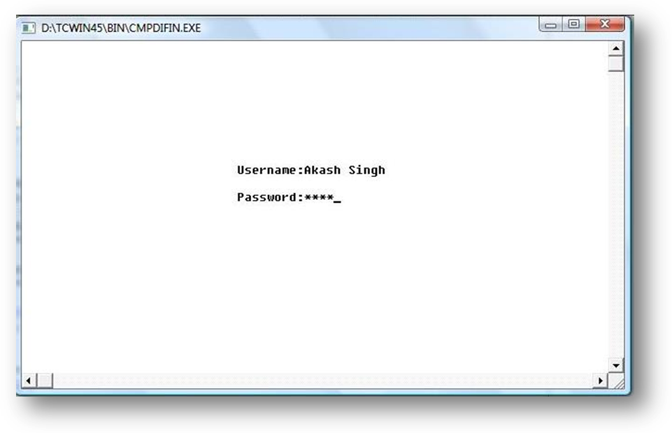

The Main Menu:
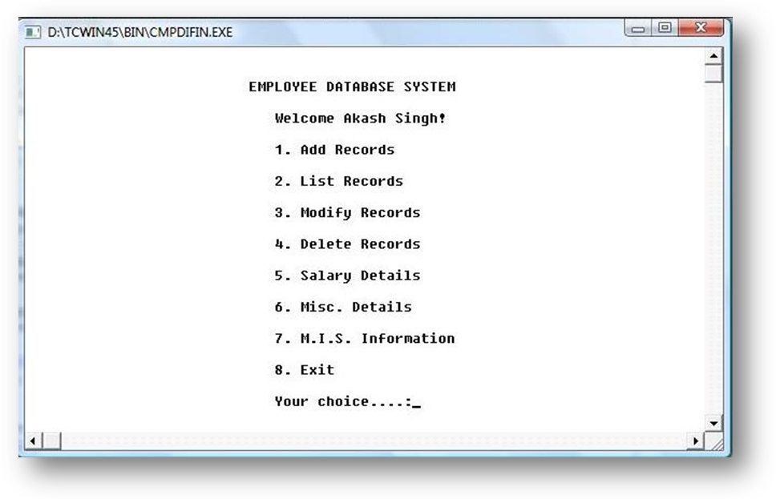
List of Records:
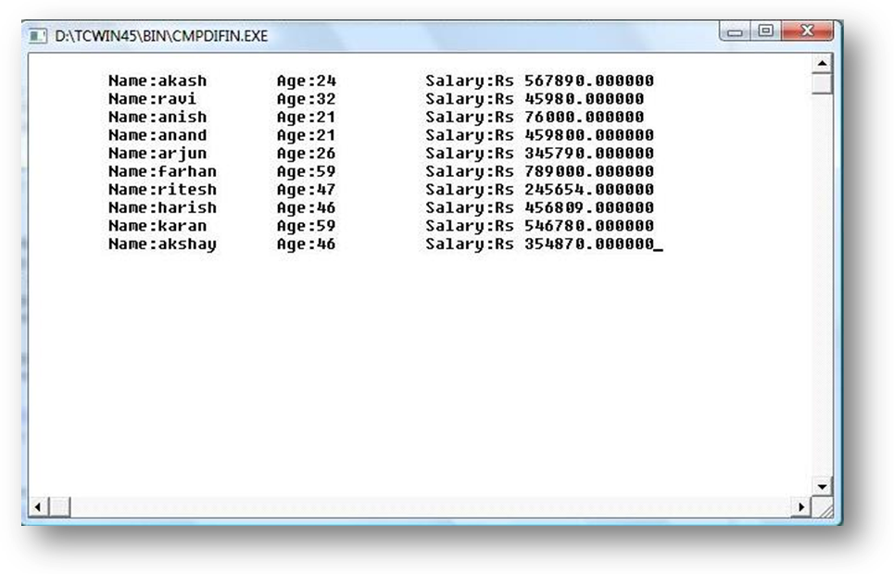
Sub Menu Screen for Misc Details:
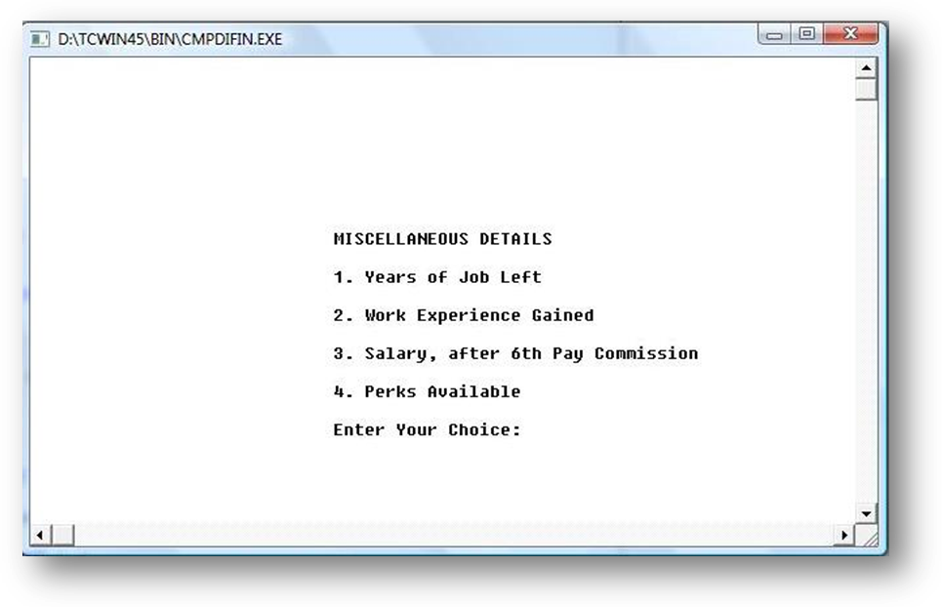
Screenshot depicting the perks available:

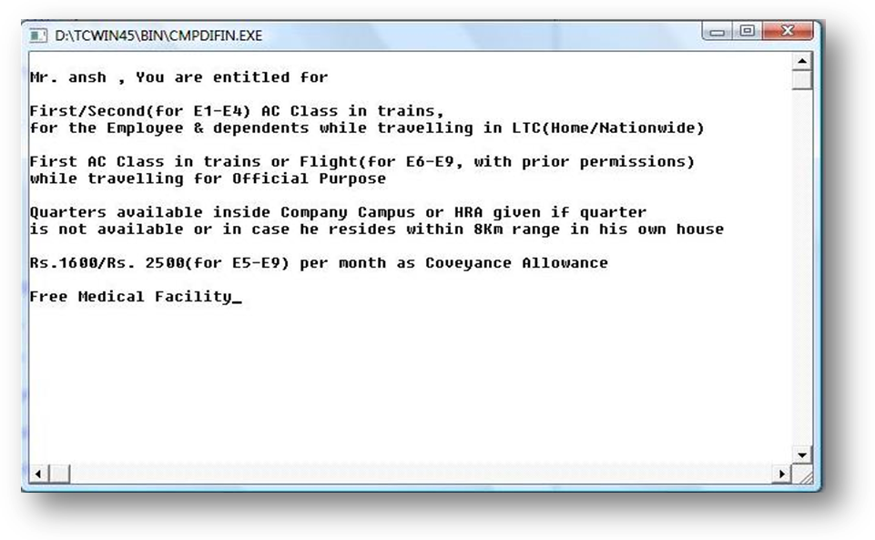
Screenshot showing submenu screen for MIS Information:

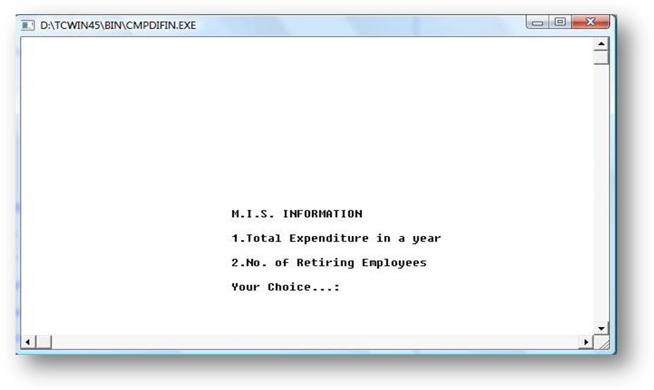
Sub Menu Screen for Salary Details:

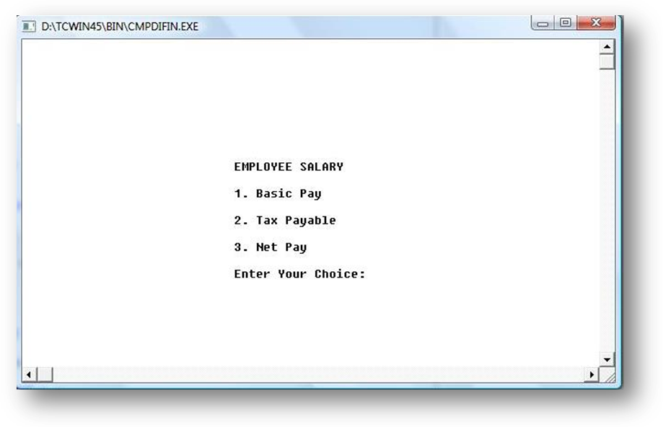
Screenshot of Salary Calculation:

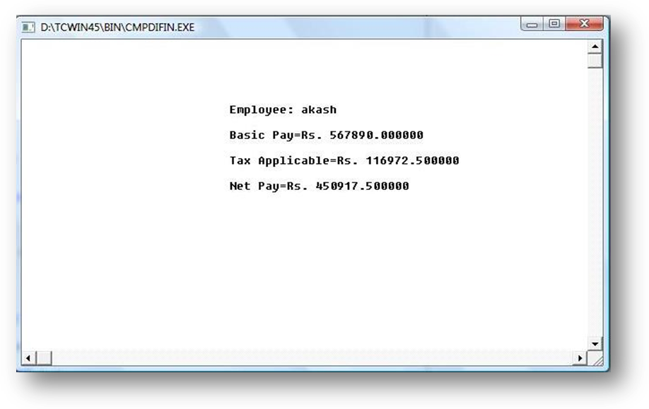

SCOPE FOR FUTURE ADVANCEMENT

Everything in this universe is bound to get better with time. The changing phenomena may be technological, ecological, or any other field, change is eminent. So, this project is no exception and this has many scopes for future advancements. This Employee Database can be more efficient, user-interactive and can handle more details. The language C itself has implemented many restrictions on the program, that can be eradicated with an advanced language like Java or VB.Net. Also, there is provision for GUI implementation instead of command line interface.

As an application this program can be integrated to the World Wide Web or any LAN. By this, the application could be accessible from anywhere in the world, i.e., an Employee having his details over this application is able to check his details from anywhere in the world just with a few mouse-clicks over the Internet. So, with the help of new technologies more security level could be attained, like using any database software, like Oracle, Access, etc. the username and password for the database will add to the security of the application.

This project is just a miniature form or replica of an application that are commercially used in present time. This project includes all the features of a new application, but in lower versions. This has to be developed into a generalised, platform independent and commercialised product that can be utilized in the real world for serving the purpose of my problem statement.

